**Project Initialization and Planning Phase**

|  |  |
| --- | --- |
| Date | 6 October 2025 |
| Team ID | xxxxxx |
| Project Title | Predicting Plant Growth Stages with Environmental and Management Data Using Power BI |
| Maximum Marks | 3 Marks |

**Project Proposal (Proposed Solution) template**

**1. Project Background**

**Problem Statement**: Commercial Growers and researchers lack clear, quantified insights to reliably determine the exact combination of environmental factors and care protocols that drives the highest success rate in achieving the plant's Growth Milestone. The current data lacks a mechanism for visual, interactive analysis to establish optimal operational ranges.

**Project Goal**: To leverage the provided plant growth dataset to define the Optimal Growth Protocol and Environmental Window that consistently leads to successful growth outcomes.

**2. Proposed Solution**

The solution is the development of a comprehensive and interactive Power BI Dashboard that visualizes the complex relationships between the six input variables and the binary growth outcome**.**

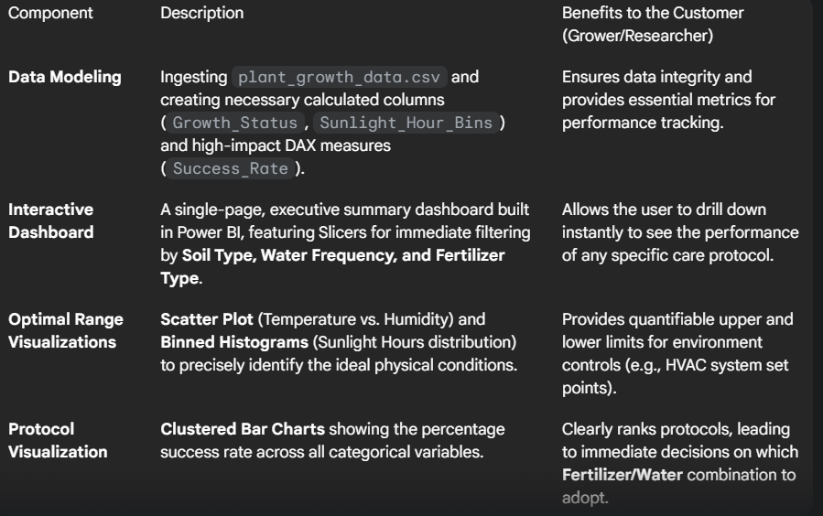

**3. Methodology & Tools**

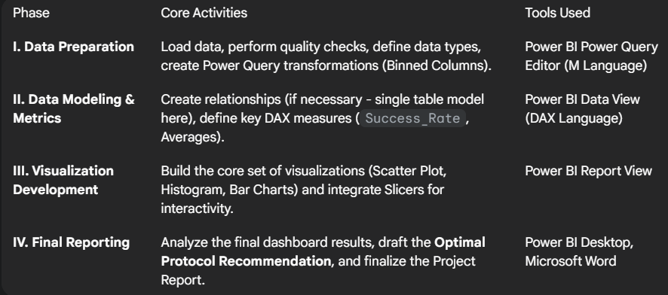

**4. Project Timeline**

The project will be executed over [Specify Duration, e.g., 2 Sprints / 10 Days], ensuring a rapid transition from raw data to actionable business intelligence.

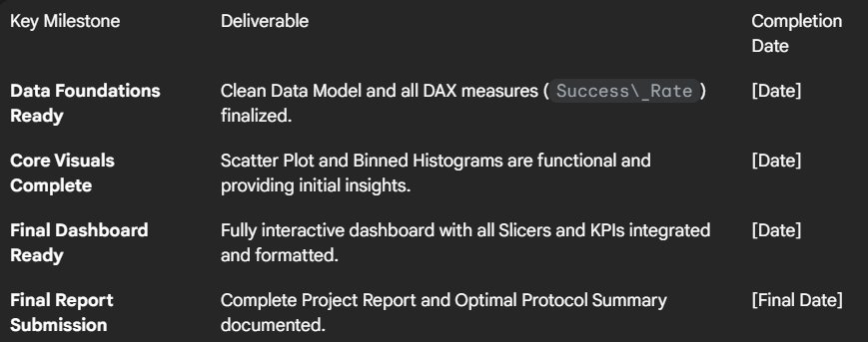

**Resource Requirements**

|  |  |  |
| --- | --- | --- |
| **Resource Type** | **Description** | **Specification/Allocation** |
| **Hardware** | | |
| Computing Resources | CPU/GPU specifications, number of cores | e.g., 2 x NVIDIA V100 GPUs |
| Memory | RAM specifications | e.g., 8 GB |
| Storage | Disk space for data, models, and logs | e.g., 1 TB SSD |
| **Software** | | |
| Frameworks | Python frameworks | e.g., Flask |
| Libraries | Additional libraries | e.g., scikit-learn, pandas, numpy |
| Development Environment | IDE, version control | e.g., Jupyter Notebook, Git |
| **Data** | | |
| Data | Source, size, format | e.g., Kaggle dataset, 10,000 images |